Swissvoice C50 Seniors Mobile

Type of device: Mobile
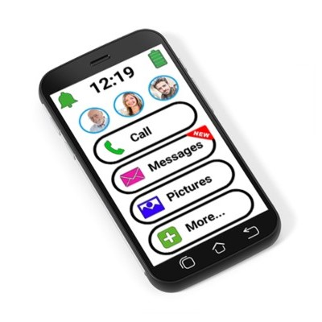

Actual Display Size : 5"
Button Type : Touchscreen
Operating System : Android
Version Number : 7
Network Capability : 3G,4G
Average Price : $599 as of 31 01 2020

Accessibility Features:

Cognitive
- GPS
- Photo Telephone List
Simplify Display

Hearing Impairment and Deaf
- Bluetooth or Wi-Fi
- Hearing Aid Microphone Coupling
- Hearing Aid Telecoil Coupling
- Text Messaging/SMS
- Vibrating Alerts - Adjustable
Visual Alerts - Incoming Calls

Vision
- Battery Alert - Audible
- Bluetooth or Wi-Fi
- Dictation / Speech-to-Text
- Personalised Shortcuts
- Power Cue
Voice Control /Personal Assistant

Speech
Bluetooth or Wi-Fi

Physical
- Bluetooth or Wi-Fi
- Dictation / Speech-to-Text
- Flat Back for Table Top Operation
- Headset - plug connected
- Speaker-phone option
- Switch control option
- Voice Control / Personal Assistant
Voice Recognition for Dialling

How and where to get it from?
You can buy this phone from Southern Phone, and other retailers.

More information is available on:
Swissvoice C50s Seniors Mobile Webpage
Swissvoice C50s Seniors Mobile User Manual (PDF Download)
Swissvoice C50s Seniors Mobile Introduction YouTube Video
Accessibility Features (PDF Download)

